Important Changes to Your Testing Regime
Dear Colleague,

Firstly, we want to thank you for all your efforts and support of the testing programme from the outset. We are grateful to you for working with us to continue to protect the lives of colleagues, and the vulnerable people you care for.

Secondly, as the country moves from Plan B with the removal of restrictions, an announcement [link to press notice] today set out changes to the testing and self-isolation guidance for care homes that will be introduced following advice given by the Scientific Advisory Group for Emergencies (SAGE) to ensure you and your residents remain protected from Covid-19, as well as reducing restrictions on visiting and self-isolation for residents. This newsletter provides more detail about these changes and next steps for you. Full guidance will be published next week.
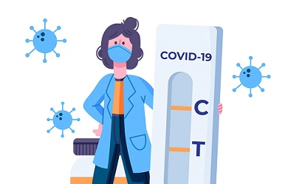

Staff Testing Updates
- An enhanced testing regime of pre-shift Lateral Flow Tests (LFDs) for all staff on each of the days they are working, and the removal of the weekly asymptomatic PCR testing for staff.
- There will be no change to PCR testing for staff symptomatic testing, outbreak or any other PCR testing for staff eg when they are a contact
Based on current SAGE Social Care Working Group advice, following the pre-shift testing regime provides better protection than the current regular testing regime of weekly PCR with three lateral flow tests a week. The introduction of pre-shift rapid lateral flow tests should help identify and isolate positive cases more quickly rather than waiting for PCR results to return from the lab.

From Friday 28 January, when you place an order for staff LFDs, we will send you enough LFDs for all your staff to undertake pre-shift LFDs for everyday they are working. These can be used either on-site or at home by staff members. If you are within 21 days of your last order and need more tests to follow the enhanced testing regime, please call 119. We are asking all care homes to implement these testing changes by the 16th February.

Resident Testing and Self Isolation Updates
As the situation is improving, and we know more about the virus, we are able to follow the latest scientific advice and reduce restrictions on visiting in care homes while scaling back isolation requirements. A high level overview of these changes are:
- Self-isolation periods for those who test positive will be brought in line with the general public so reduced from fourteen to maximum ten days and can be further reduced with two negative LFD tests 24 hours apart from day 5 and 6 onwards
- Isolation periods for those in care following an emergency hospital visit will be reduced from 14 to a maximum of 10 days
- There will be no testing or self-isolation requirements for residents following normal visits out
- Further amendments in isolation periods and testing requirements for residents who are contacts, have been on a high-risk visit out, and have had an emergency visit to hospital.
- There will be no change to testing if a resident is symptomatic, regular monthly asymptomatic PCR testing, any outbreak testing for residents.
You can find more details of all the changes detailed above in this letter from
Claire Armstrong - Director of Adult Social Care Delivery and Covid-19 Response,
Department of Health and Social Care. In addition, full guidance documents will be published next week on the existing pages for testing , visiting , and admissions.

Thank you,
NHS Test and Trace

